Later we will be discussing indexes and table of contents. These are activated by the styles Heading 1, 2, and 3. But, what is a style. A style is a combination of formats, both paragraph and character (although the character works on the entire paragraph). Style itself is can be either a paragraph or character command but for our class, we will create new ones as paragraph commands.

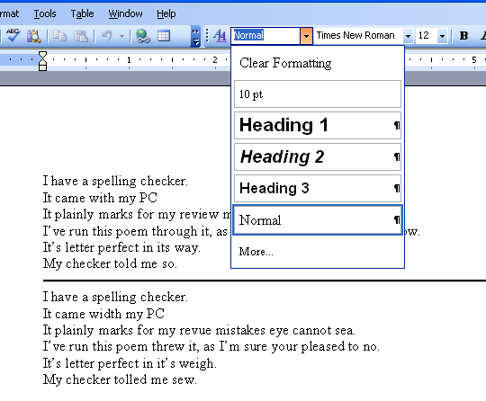
To the right is the display of style – this is the box to the left of font selection. In this case, Headings 1,2 and 3 are most prominent. But there are many such styles which you could look at now.

How do we set a style and what is it good for. Let’s answer the second question first. With the availability of the format painter – that’s the copier on the system icon bar – styles have lost some of their impact. But, they still can play their part in large documents where non contiguous paragraphs need special work.

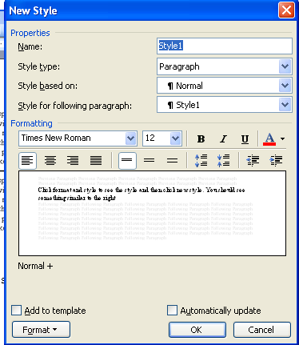
So, let’s get to the first question. How do we set a style?

Click format and style to see the style and then click new style. You should see something similar to the right. You have the opportunity to name your style – don’t use the default style 1. You can choose a template of a style – in this case we can use Normal 1 and then there is almost a redoing of the format toolbar that you can set. Additionally, by selecting the format button, an almost duplication of the format menu item is displayed for you also to use. The text in the listbox displays your selections as you go.

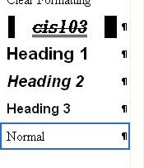
Below left shows a style where border, las vegas lights, space above and below, strikethroughs, etc has been created. A hot key of alt C has also been instituted which is shown to the right. We have called this style CIS103 (which you can see to the right. To invoke this style, either click anywhere on a paragraph and click on CIS103, or even better, hit alt C when in the paragraph.

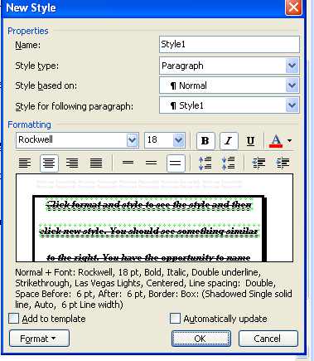
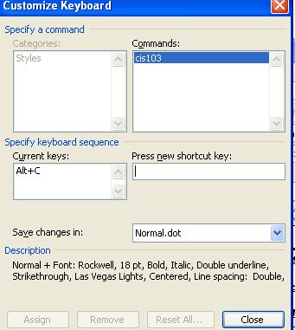
Let’s try it

Well, what do you think

